C# Web Development Basics – Regular Exam

PANDA
PANDA (Package Acceptance and National Delivery Application) is a platform for package deliveries, which is a fast-rising Start-Up, which lacks a web application. You have been employed by the KFC (Kung-Fu-Chicken) Corporation to implement a web platform for PANDA. However, there are specific requirements that must be followed.

Technological Requirements
- Use the SIS.WebServer
- Use the SIS.Framework or the Niki.Framework
- Use Entity Framework Core
The Technological Requirements are ABSOLUTE. If you do not follow them, you will NOT be scored for other Requirements.
Now that you know the Technological Requirements, let us see what are the Business Requirements.

Database Requirements
The Database of the PANDA application needs to support 3 entities:

User
- Has an Id – a GUID String or an Integer.
- Has an Username
- Has a Password
- Has an Email
- Has an Role – can be one of the following values (“User”, “Admin”)

Package
- Has an Id – a GUID String or an Integer.
- Has a Description – a string.
- Has a Weight – a floating-point number.
- Has a Shipping Address – a string.
- Has a Status – can be one of the following values (“Pending”, “Shipped”, “Delivered”, “Acquired”)
- Has an Estimated Delivery Date – A DateTime object.
- Has a Recipient – a User object.

Receipt
- Has an Id – a GUID String or an Integer.
- Has a Fee – a decimal number.
- Has an Issued On – a DateTime object.
- Has a Recipient – a User object.
- Has a Package – a Package object.

Implement the entities with the correct datatypes.

Template Requirements

Guest Templates
These are the templates and functionalities, accessible by Guests (logged out users).

Index Template (route = “/Home/Index”) (logged out user)
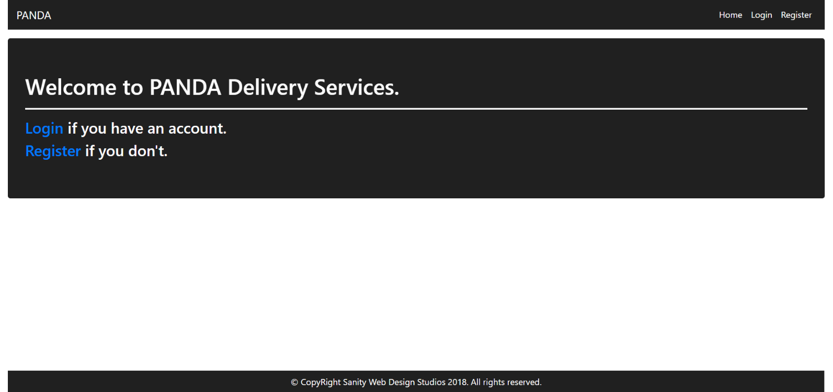

Login Template (route = “/Users/Login”) (logged out user)
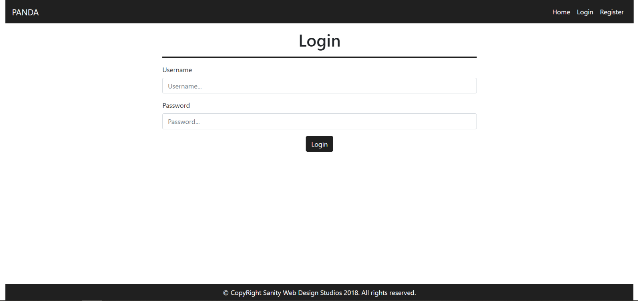

Register Template (route = “/Users/Register”) (logged out user)
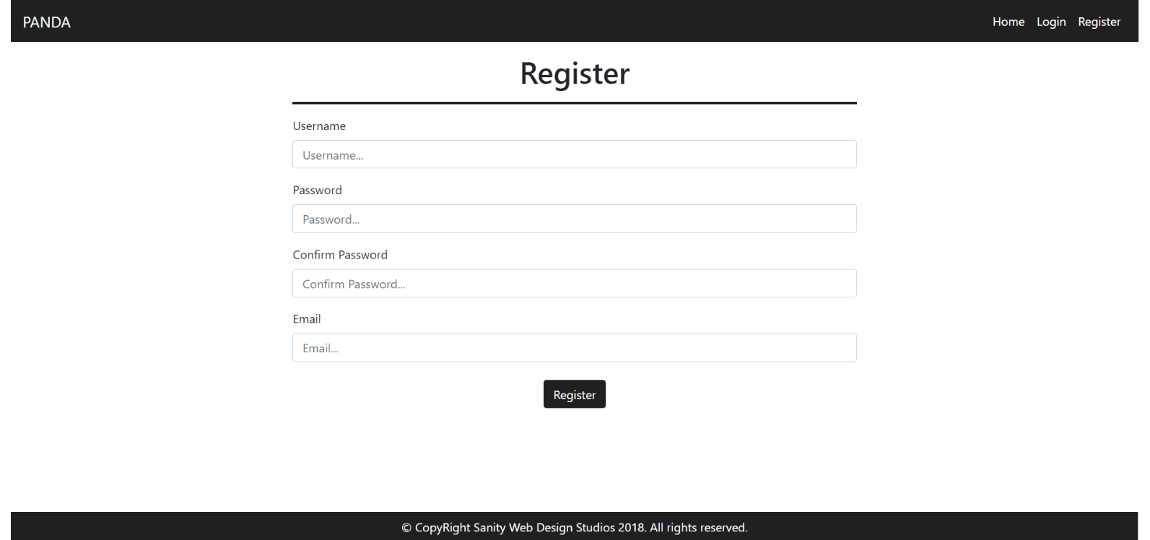

User Templates
These are the templates and functionalities, accessible by Users (logged in users with Role - User).

LoggedIn Index Template (route=”/Home/Index”) (logged in user)
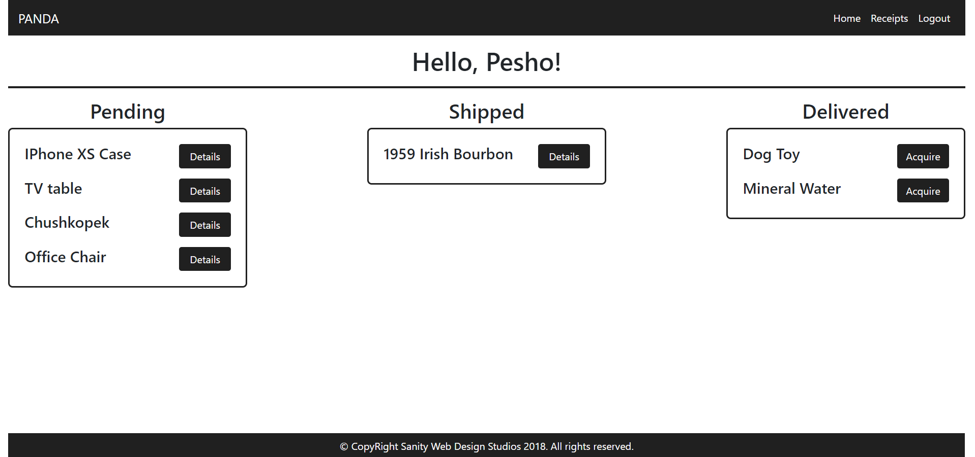

Package Details Template (route=”/Packages/Details?id={id}”) (logged in user)
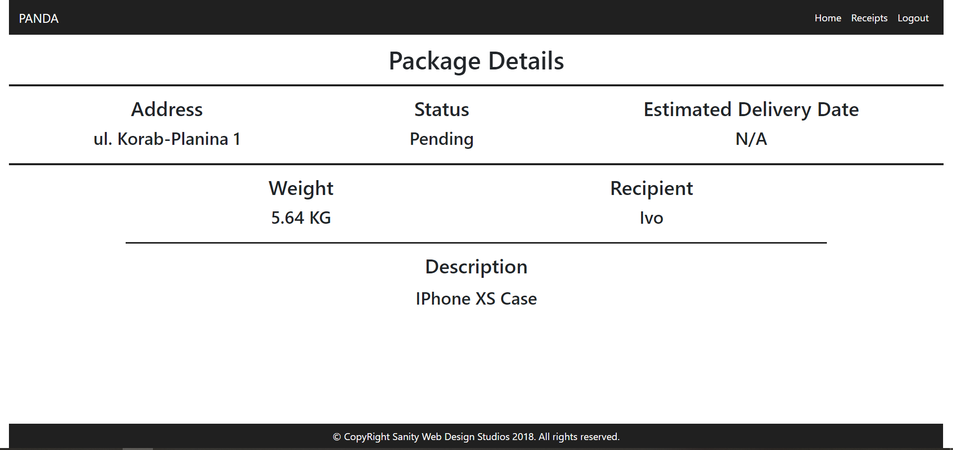
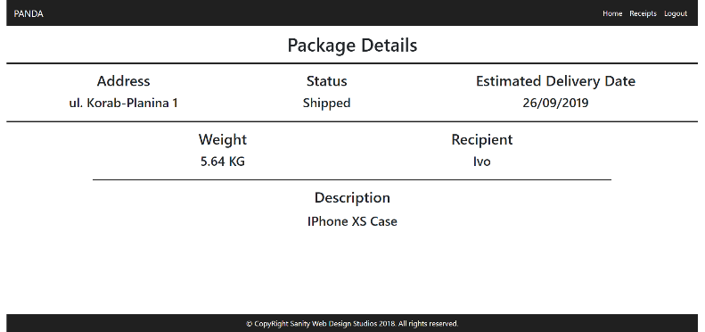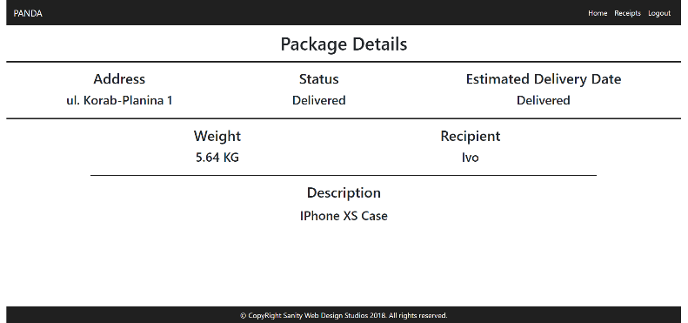
NOTE:
- If the package’s status is Pending, it should NOT have an Estimated Delivery Date, and “N/A” should be presented.
- If the package’s status is Shipped, it will have an Estimated Delivery Date. In that case the date should presented instead of “N/A”. (Example: “29/02/2016”).
- If the package’s status is Delivered or Acquired, instead of the date, “Delivered” should be presented.

Receipts Template (route=”/Receipts/Index”) (logged in user)
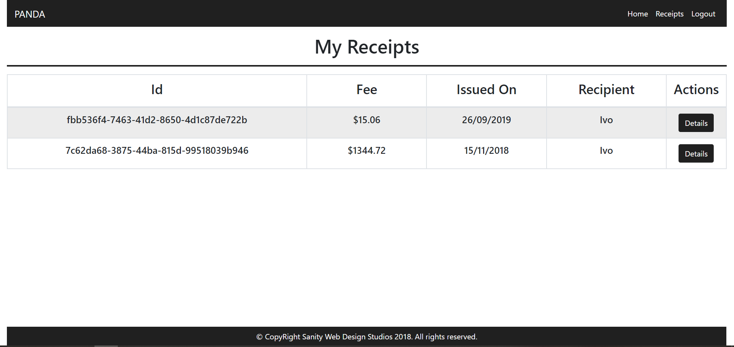

Receipt Details Template (route=”/Receipts/Details?id={id}”) (logged in user)
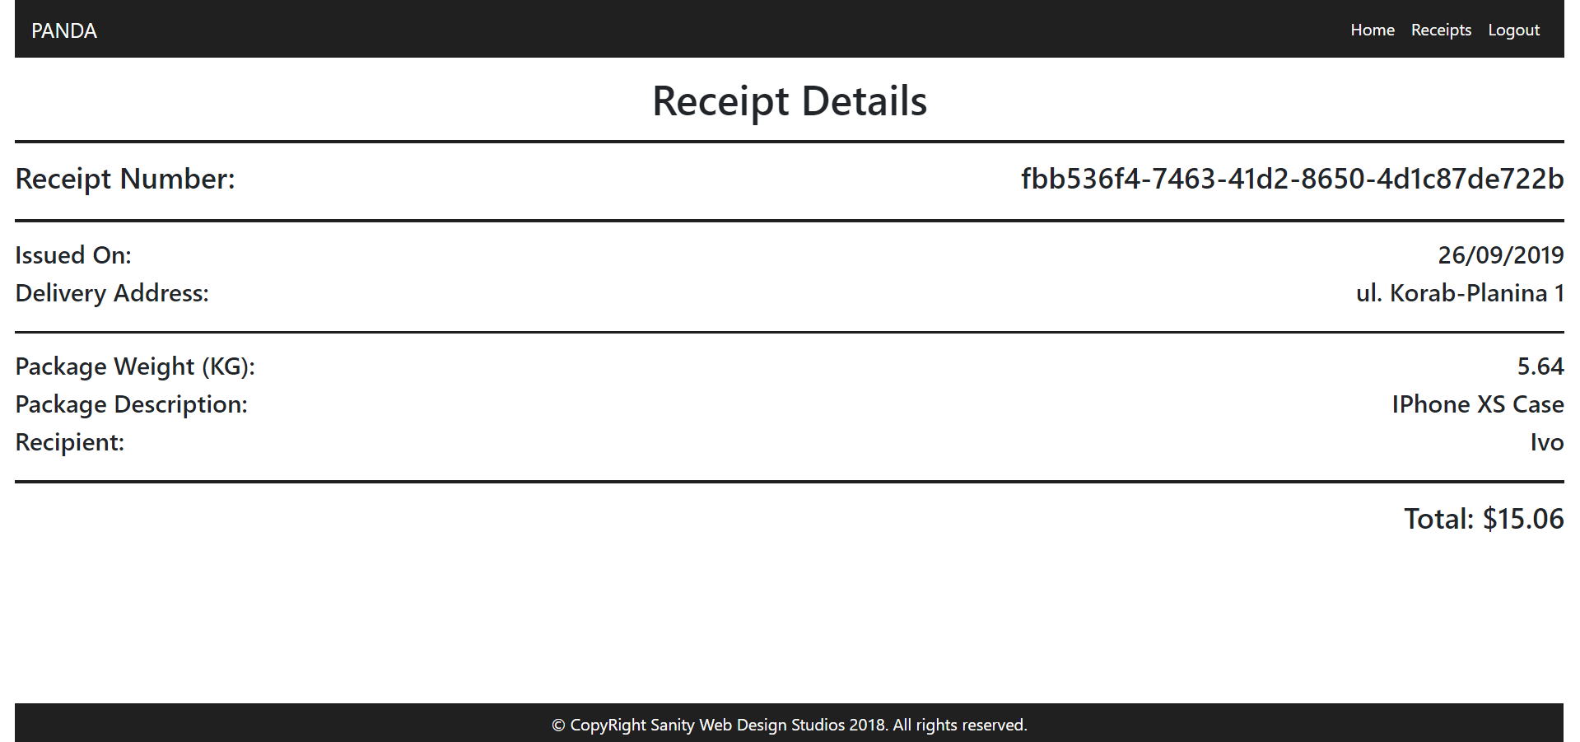

Admin Templates
These are the templates and functionalities, accessible by Admins (logged in users with Role - Admin).

Admin Index Template (route=”/Home/Index”) (logged in admin)
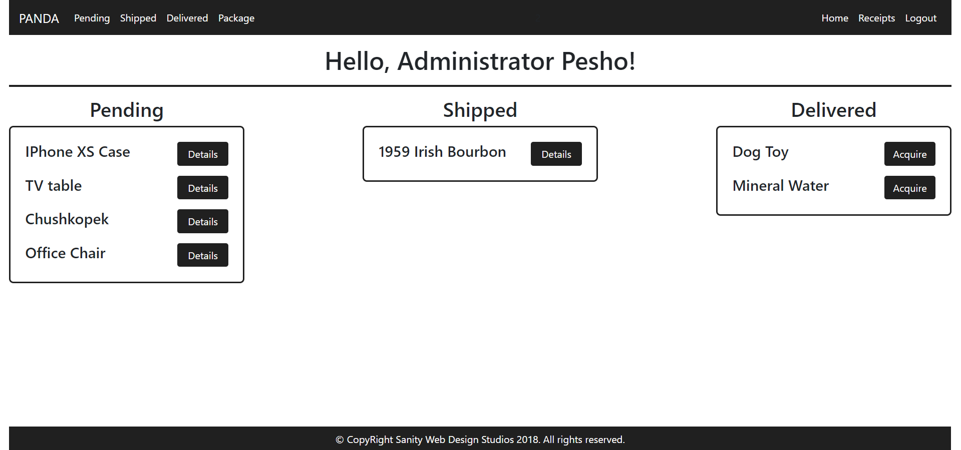
The navigation links above should lead to:
- [Pending] – Pending Packages
- [Shipped] – Shipped Packages
- [Delivered] – Delivered Packages
- [Package] – Create Package

Package Details Admin Template (route=”/Packages/Details?id={id}”) (logged in admin)
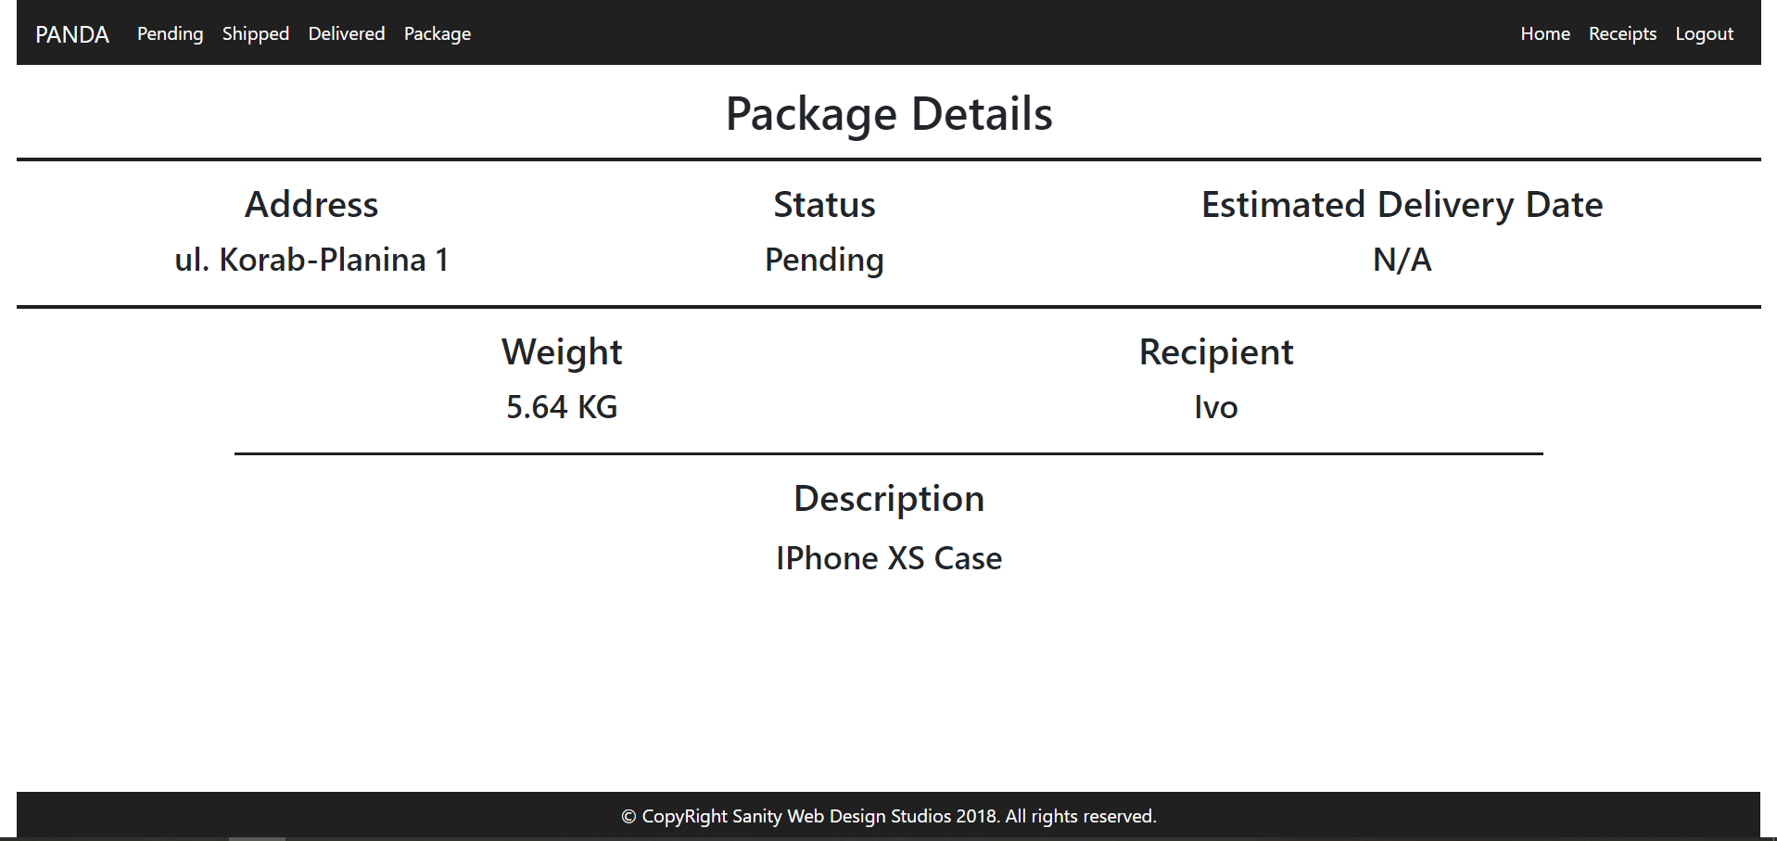

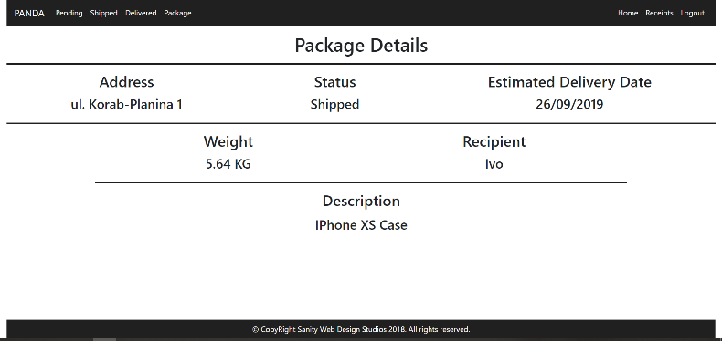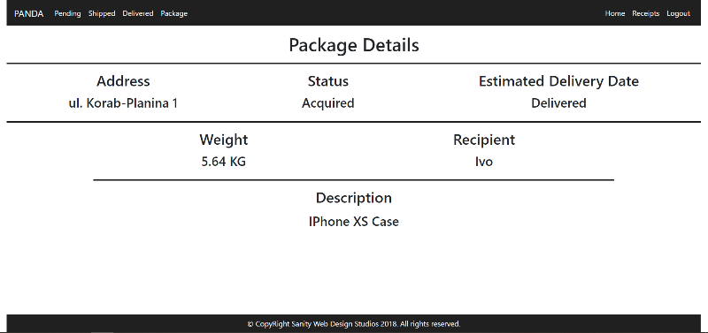

NOTE:
- If the package’s status is Pending, it should NOT have an Estimated Delivery Date, and “N/A” should be presented.
- If the package’s status is Shipped, it will have an Estimated Delivery Date. In that case the date should presented instead of “N/A”. (Example: “29/02/2016”).
- If the package’s status is Delivered or Acquired, instead of the date, “Delivered” should be presented.

Receipts Admin Template (route=”/Receipts/Index”) (logged in admin)
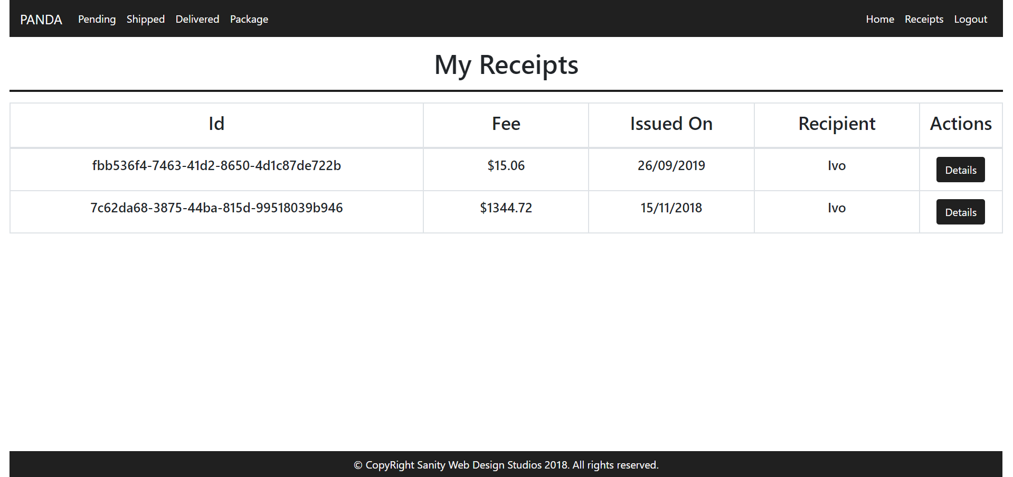

Receipt Details Admin Template (route=”/Receipts/Details?id={id}”) (logged in admin)
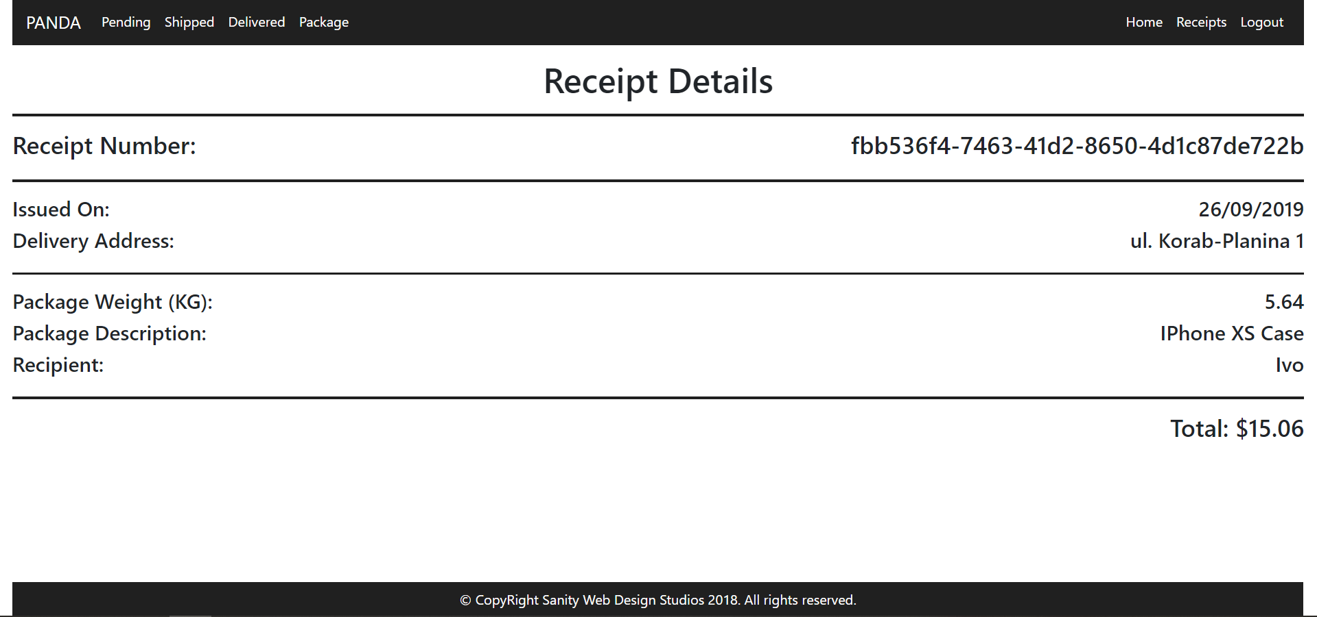

Package Create Admin Template (route=”/Packages/Create”) (logged in admin)
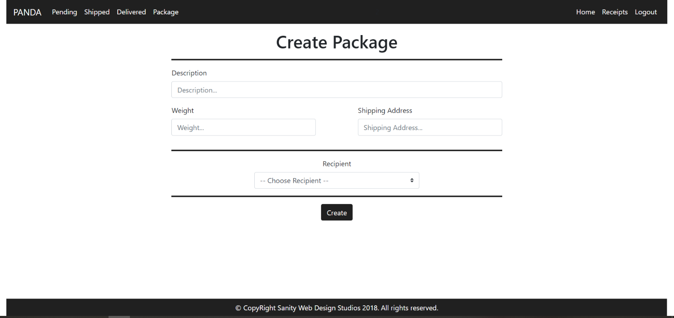

NOTE: The Recipients field is a dropdown menu, with all the registered users in the application (including yourself). The primarily selected option should be “-- Choose Recipient --" and it should be disabled, so that it cannot be selected.

Pending Packages Admin Template (route=”/Packages/Pending”) (logged in admin)
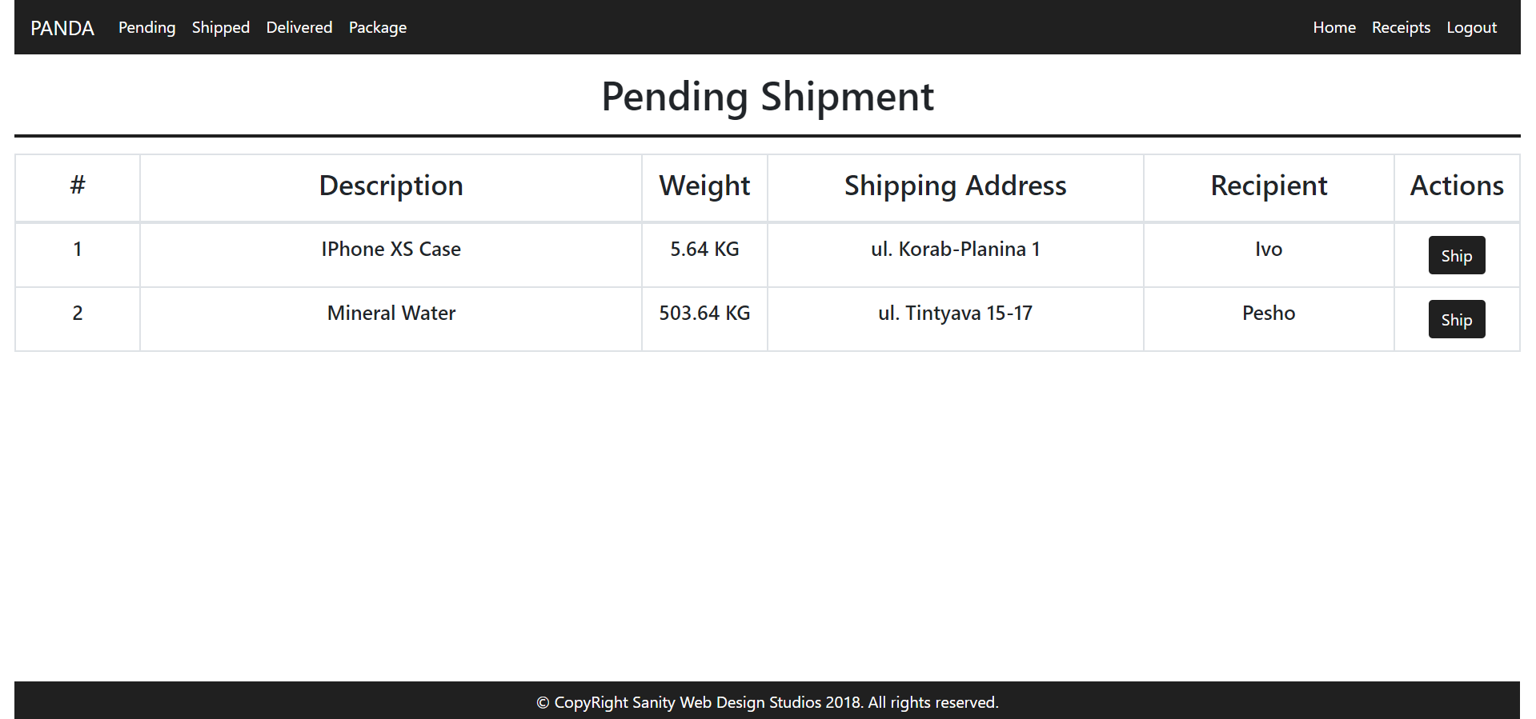

Shipped Packages Admin Template (route=”/Packages/Shipped”) (logged in admin)
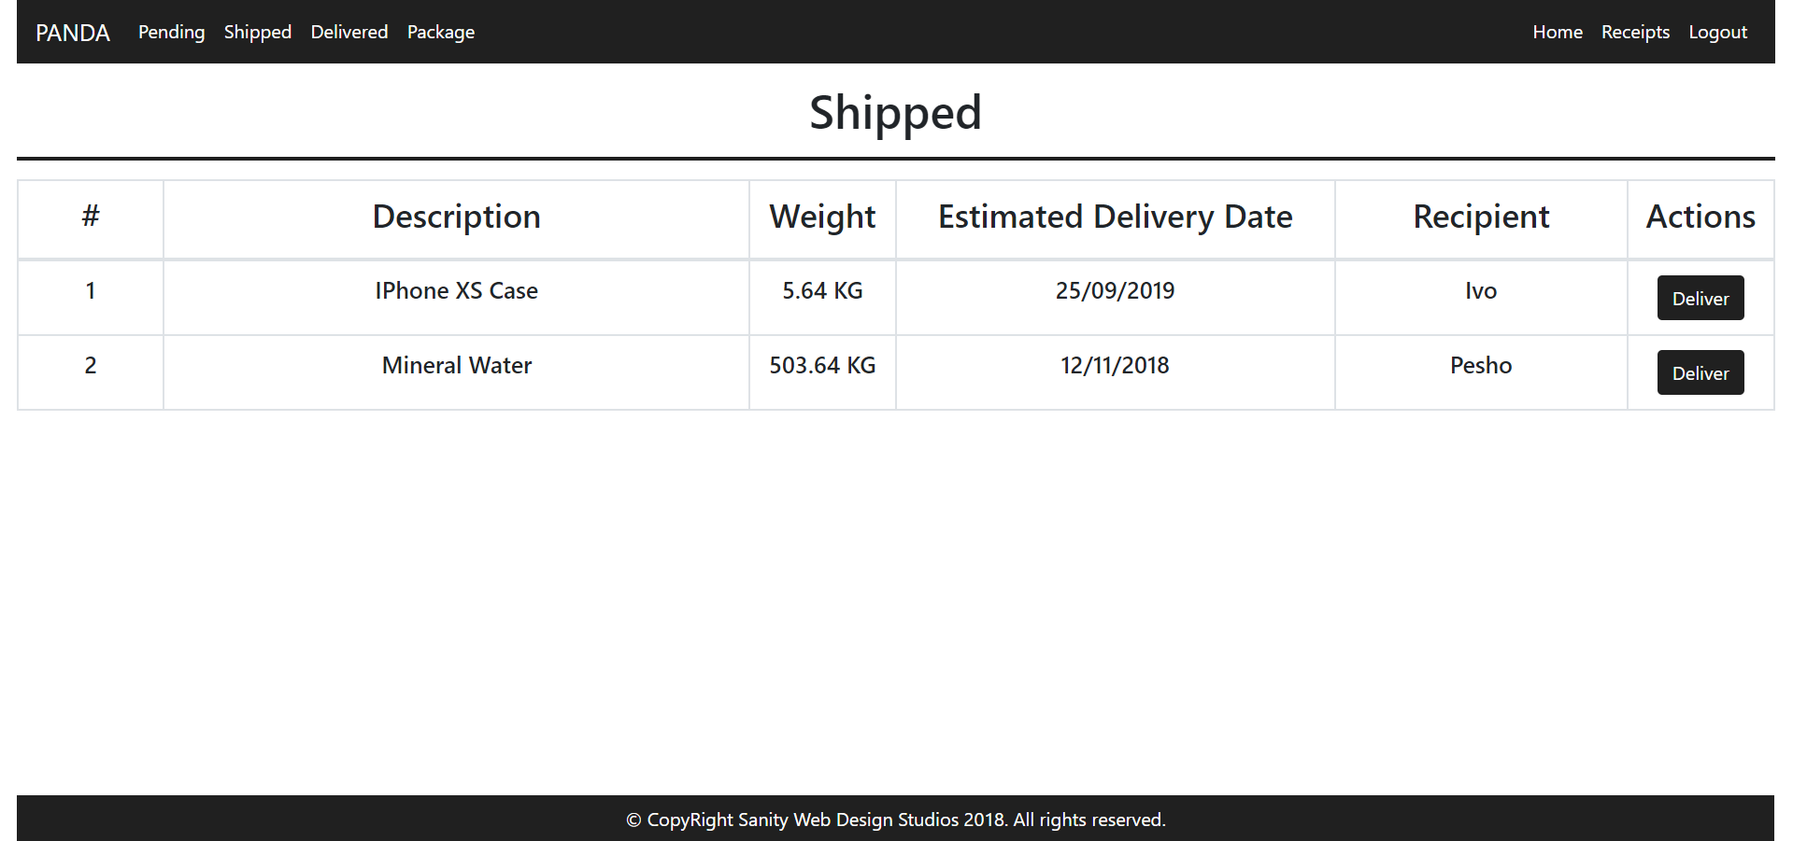

Delivered Packages Admin Template (route=”/Packages/Delivered”) (logged in admin)
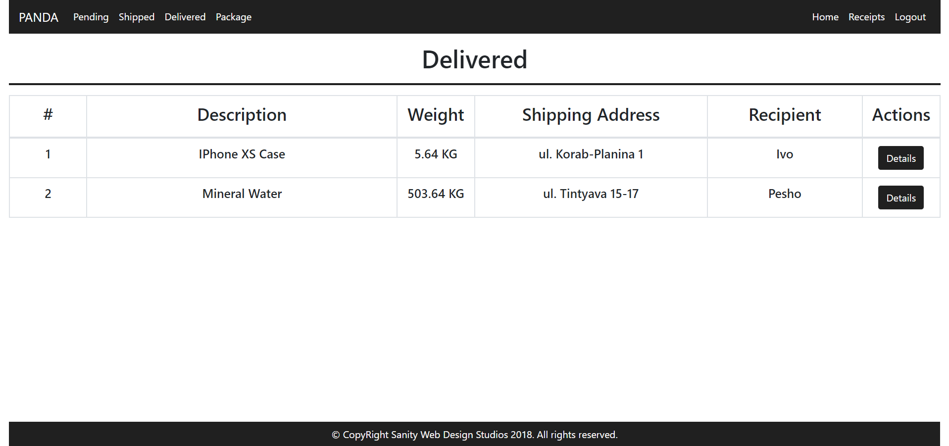

Some of the templates have been given to you in the application skeleton, but the others will be for you to implement, so make sure you implement them correctly. You can use the given ones as helpers.
NOTE: The templates should look EXACTLY as shown above.
NOTE: The templates do NOT require additional CSS. Only bootstrap and the given style.css are enough.
NOTE: In the given style.css you’ll see some helpful classes “bg-panda”, “text-panda”, “border-panda”. “border-panda” will help you with the border of the blocks on the Index Pages.

Functional Requirements
The Functionality Requirements describe the functionality that the Application must support.
The application should provide Guest (not logged in) users with the functionality to:
- Login
- Register
- View the Guest Index page

The application should provide Users (logged in) with the functionality to:
- Logout
- View their Packages
- View details about a Package
- View their Receipts
- View details about a Receipt

The application should provide Admins (logged in, with role - Admin) with the functionality to:
- Logout
- View their Packages
- View details about a Package
- View their Receipts
- View details about a Receipt
- View all Pending Packages
- View all Shipped Packages
- View all Delivered Packages
- View details about all Delivered Packages
- Ship Packages
- Deliver Packages

Users
The first registered User, should be assigned a role – “Admin”. Every User after that, should have a role – “User”.
Users have Packages, which are created and controlled for them, by an Administrator. Users can view Details about their own Packages. When a Package is delivered, a User can acquire it, at which point a Receipt is created with that Package and that User. Users can view their Receipts, and details about each Receipt.
Administrators (role = “Admin”) are essentially like normal Users. They can also have Packages, which are delivered, acquired and they also have Receipts. Administrators can also create Packages for a specific User.
- They can also view all Pending Packages, and they can Ship them.
- They can also view all Shipped Packages, and they can Deliver them.
- They can also view all Delivered Packages, and they can view Details about them.

Packages
When Packages are created, they are created with a Description, a Weight, a Shipping Address and a Recipient User.
- Upon creation, the Status of a Package should be set to Pending.
- Upon creation, the Estimated Delivery Date of a Package should be set to NULL.

Functionality

Pending Packages
A Pending Package, can be Shipped by an Administrator, by clicking on the [Ship] button from the Pending Packages Page. At that moment the Package Status becomes “Shipped” and the Estimated Delivery Date is to be set to a random of 20-40 days from then.
- All Pending Packages are presented on the Pending Packages Page.
- A User can view his Pending Packages on his Index Page in the Pending rectangular block.
- A User can view details about each one of his Pending Packages from his Index Page, by clicking on the [Details] button.

Shipped Packages
A Shipped Package, can be Delivered by an Administrator, by clicking on the [Deliver] button from the Shipped Packages Page. At that moment the Package Status becomes “Delivered”.
- All Shipped Packages are presented on the Shipped Packages Page.
- A User can view his Shipped Packages on his Index Page in the Shipped rectangular block.
- A User can view details about each one of his Shipped Packages from his Index Page, by clicking on the [Details] button.

Delivered Packages
A Delivered Package, can be Acquired by the Package’s Recipient, by clicking on the [Acquire] button from his Index Page. At that moment the Package Status becomes “Acquired” and a Receipt is generated to the User for that Package.
- All Delivered Packages are presented on the Delivered Packages Page.
- A User can view his Delivered Packages on his Index Page in the Delivered rectangular block.
- A User can Acquire each one of his Delivered Packages from his Index Page, by clicking on the [Acquire] button.
NOTE: The INDEX PAGE visualizes ONLY the CURRENTLY LOGGED IN USER / ADMIN’s PACKAGES.
NOTE: Acquired Packages are viewable only by Administrators on the Delivered Packages Page.
NOTE: Administrators can view details about ALL Delivered / Acquired Packages from the
Delivered Packages Page, by clicking on the [Details] button.

Receipts
Receipts are just data entities. They are created when a Package is Acquired by its Recipient User.
A Receipt should be created with a Package and a Recipient User.
Upon creation, a Receipt’s Fee should be set to the Package’s Weight multiplied (*) by 2.67.
Upon creation, a Receipt’s IssuedOn should be set to the current moment.

Security Requirements
The Security Requirements are mainly access requirements. Configurations about which users can access specific functionalities and pages.
- Guest (not logged in) users can access Index page and functionality.
- Guest (not logged in) users can access Login page and functionality.
- Guest (not logged in) users can access Register page and functionality.
- Users (logged in) can access User LoggedIn Index page and functionality.
- Users (logged in) can access User Package Details page and functionality.
- Users (logged in) can access User Receipts page and functionality.
- Users (logged in) can access User Receipt Details page and functionality.
- Users (logged in) can access User Package Acquire functionality.
- Users (logged in) can access Logout functionality.
- Admins (logged in) can access every functionality a normal logged in User can.
- Admins (logged in) can access Admin LoggedIn Index page and functionality.
- Admins (logged in) can access the Admin Package Create page and functionality.
- Admins (logged in) can access the Admin Pending Packages page and functionality.
- Admins (logged in) can access the Admin Shipped Packages page and functionality.
- Admins (logged in) can access the Admin Delivered Packages page and functionality.
- Admins (logged in) can access the Admin Package Ship functionality.
- Admins (logged in) can access the Admin Package Deliver functionality.

Scoring
This section describes how the scoring of the Exam will be made.

Database Requirements – 10 points.

Template Requirements – 30 points.

Functional Requirements – 50 points.

Security Requirements – 10 points.

